
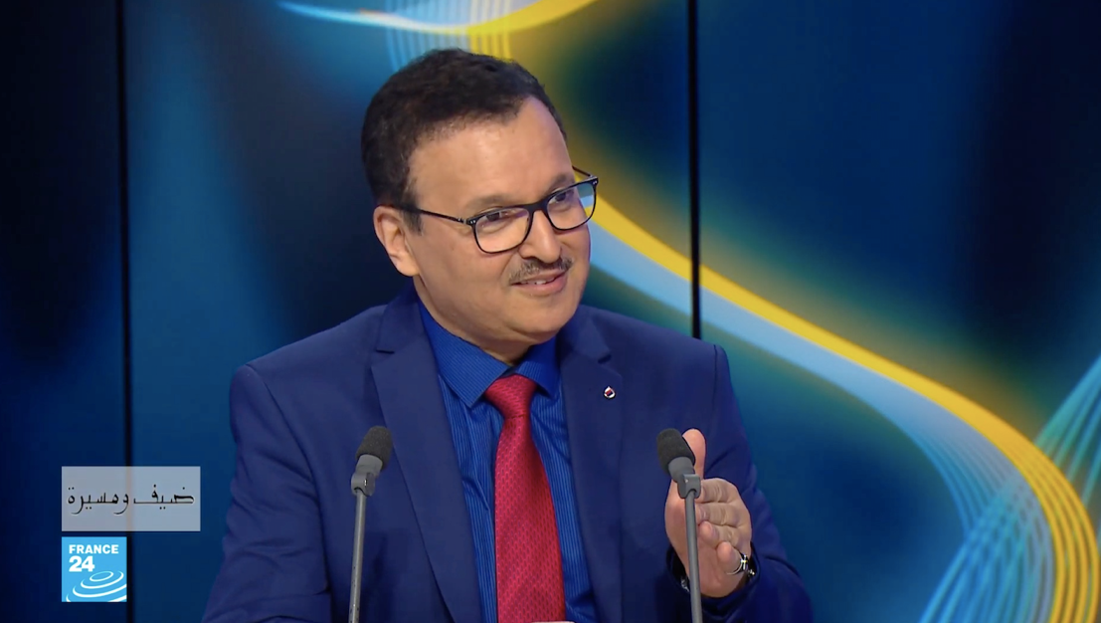

Name : Waheed Ahmed Alkhan
Born in Muharraq – kingdom of Bahrain

A Bahraini Composer, multimedia show designer and a businessman. with broad exposure across music, entertainment skills.

Graduated from the Cairo Conservatory of Music with a Bachelor Degree, then a Master Degree in Ethnomusicology. Likely studied in the conservatory of Cairo with very reputed instructors from the X Soviet union during the cultural cooperation between Egypt and the X Soviet Union.

Waheed studied under international professors such as Dr. Martha Roy - USA, Dr. Margit Tooth – Hungary, Sokolov - Russia , professor Safwat Kamal – Egypt, ,his mentor Professor Dr. Samha Al Khooly, and many other International instructors
CAREER HISTORY:
Bahrain:

- The Classic Institute of Music- (Founder / MD)
- Madar Arts Production. (MD)
- Madar Media – Waheed Alkhan W.L.L.

Dubai:

- Madar Business Development –
(President)
- Elpyro Fireworks – (MD)
- Al Safwa Islamic Financial Services – (Founder / MD)
- Madar Events & Production – (MD)

EDUCATION

1986
The Cairo Conservatory - Master Diploma in Ethnomusicology

1982
The Cairo Conservatory -
Bachelor Degree in Oboe & Piano

1980
The American University in Cairo
Certificate in Completing Computer Science

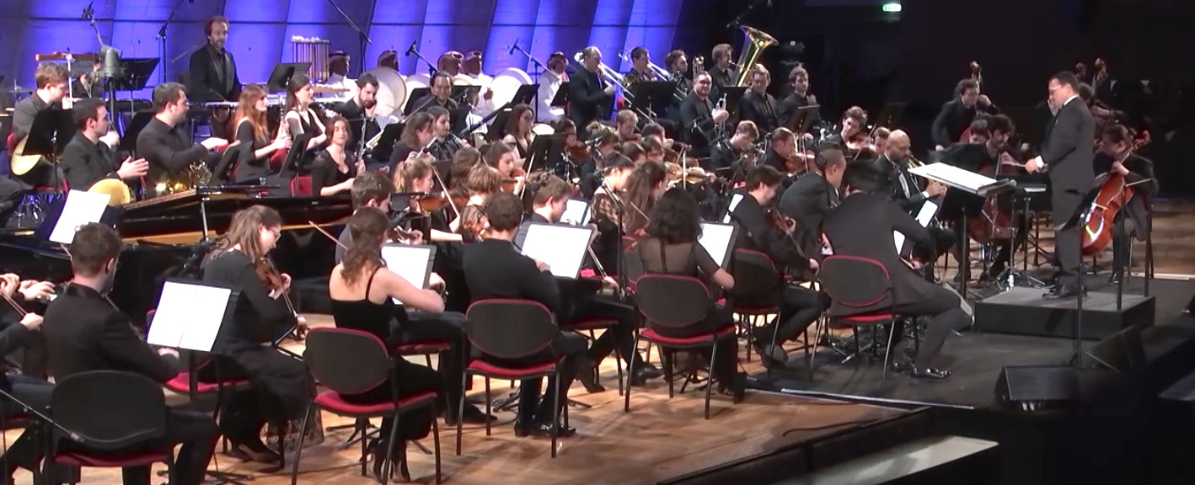

Music Career
Waheed started his musical career very actively during the 80s, then got occupied and ventured the world of business for more than 10 years and has established and run a large financial company. After that, he then decided to make a comeback to his original passion for music.
In 1982, he established the Classical Institute of Music, the first proper music center in Bahrain. In 1989, he established the first and the largest multi-track recording studio "24 Track" system, which was the highest level of technical voice recording at that time. Waheed had composed many of the musical pieces locally and internationally.
In 1991, he was awarded the Bahrain Prize for Research for his study of “Pearl Divers Songs” in Bahrain, a musical analytical study, which is considered the only specialized study for Bahraini diving songs, until today
In July 2018, Waheed came back to his passion strongly with his album “THE RETURN - Spirit of Bahrain," which includes tracks such as My Muharraq, Our Waltz, Rise, Dance for Me, and Loyalty, to name a few, which he performed at the 27th edition of the Arab Music Festival held in Cairo in November 2018.^{[2][3]} These orchestral compositions are classified as world music and had been performed by several orchestras in different countries, including Europe and the Middle East.
Waheed Alkhan’s The Return album is professionally written for a philharmonic orchestra and oriental instruments with Bahraini flavor. This album was performed by Budapest Philharmonic Orchestra recorded in one take (all performing together) then the oriental instruments were
added. The total number of performers is 94 musicians, while the mixing and mastering is done in the UK by engineer Gareth Williams.^{[3]}

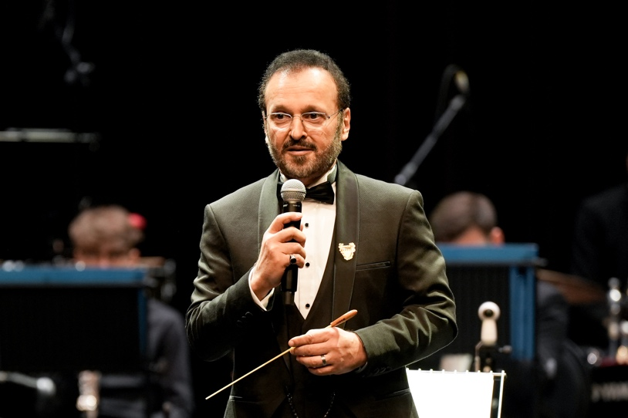

Back to Life :
In Jun 2023, Waheed had released his 2nd album “ Back to life” which was composed during the Corona Virus pandemic era, his purpose is to bring people back to the normal life activities after such depression .
This album contained 10 cheerful compositions with a deferent characteristic than his 1st album
Concerts:
- Hungary, Kodaly Hall, with Pannon Philharmonic orchestra- Sep. 2018
- Egypt ; Cairo Opera House, with Cairo Symphony orchestra - Nov. 2028.
- Kingdom of Bahrain, with Cairo symphony orchestra -Feb 2029
- France, Paris , at UNESCO head quarter, with Paris Pope Orchestra – April 2019
- Russia, Sochi : Roza Khutor Festival – with Sochi Philharmonic orchestra -Aug 2023
- Kingdom of Bahrain, with Cairo St. Petersburg Classic orchestra -Feb 2024
- Russia , Yaroslavl: with Yaroslavl Pharmacy orchestra – 16 Dec. 2026.

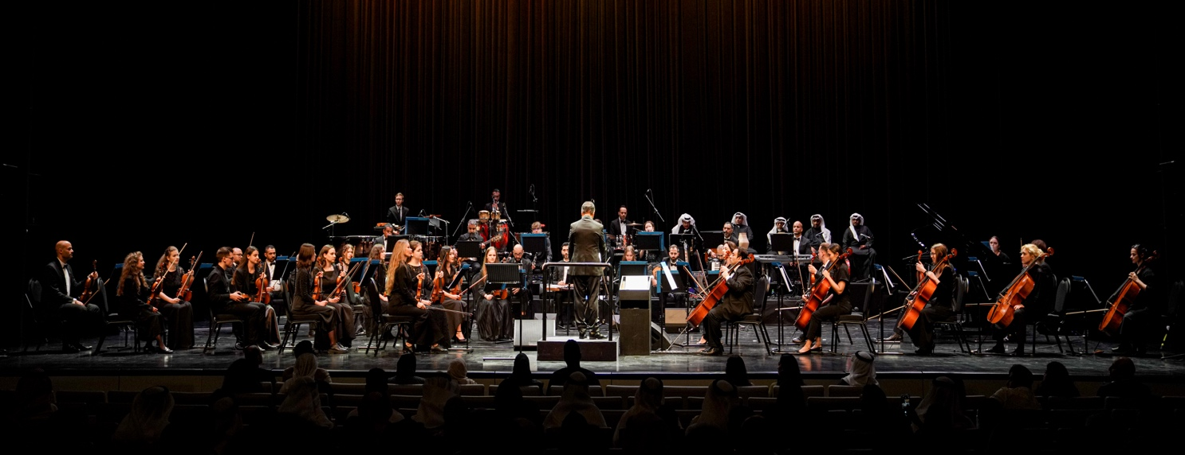
Positions held:
- President-Madar Business Development - Dubai UAE
- President -Madar Arts Production - Kingdom of Bahrain
- Managing Partner - Madar Sound and Light Systems Dubai. UAE
- Founder of the Classic institute of Music -Kingdom of Bahrain- 1982
- President - Elpyro Fireworks
- Vice Chairman & managing Director - Al Safwa Islamic Financial Service
Achievements:
- Establishing the first proper Music school in Kingdom in Bahrain. 1982
- Establishing the First Multi - Tracks Proper Audio recording studio In Kingdom of Bahrain, 1986
- Achieving the State of Bahrain Award of Scientific researched 1990
- Writing the book “Bahrain Pearl Divers Songs “published by the GCC folk Center in Qatar.
- Researching , analyzing publishing the Laiwa arts in the GCC countries
- Composing and Arranging Orchestral Music the Local TV station-The Ministry of Information of Bahrain And several events in the GCC between 1980 until 1991.
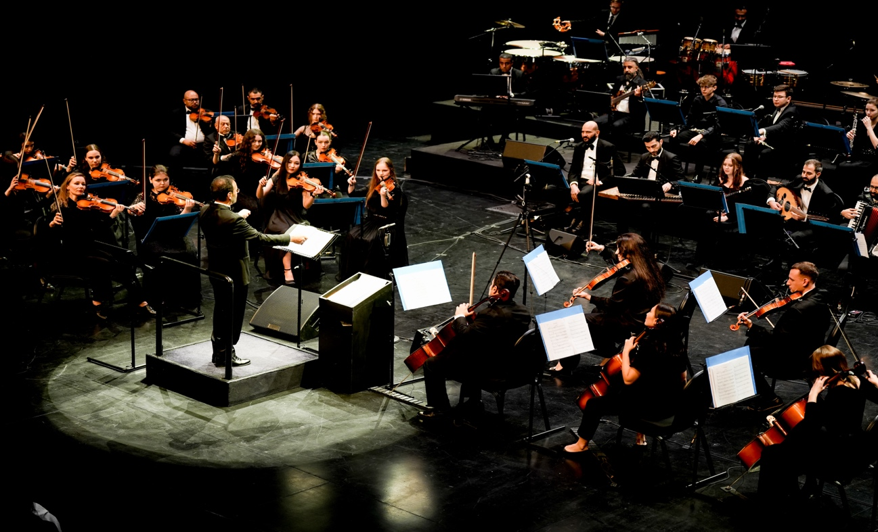
Designing major multimedia and opening ceremonies shows in the GCC like:

- The Asian Football Cup - Abu Dhabi 1996
- The Bowling world Champion Ship Opening Ceremony show Abu Dhabi 1999.
- The Jubilee Celebration of UAE university ( Al Ain) 2002.
- Arabian Woman international Opening Show ( Abu Dhabi ) 2003.
- Qatar Cultural Festival - 10 Days celebration March 2004 ( Doha )
- Bahrain national Day Celebrations 16-17-18 Dec 2003 ( Kingdom Of Bahrain)
- Bahrain national Day Celebrations 16-17 Dec 2004 ( Kingdom Of Bahrain)
- Bahrain national Day Celebration 16-17 Dec 2005 ( Kingdom Of Bahrain)
- The Opening Ceremony of Dilmun Water Park Aug 2007 ( Kingdom Of Bahrain)
- The Closing Ceremony of Dubai Shopping Festival Feb 2008 (Dubai – UAE )
- The Opening Ceremony of South East games of Handicapped March 2008 ( UAE)
- The Opening Ceremony of the Cultural Scientific association May 2008( Dubai –UAE

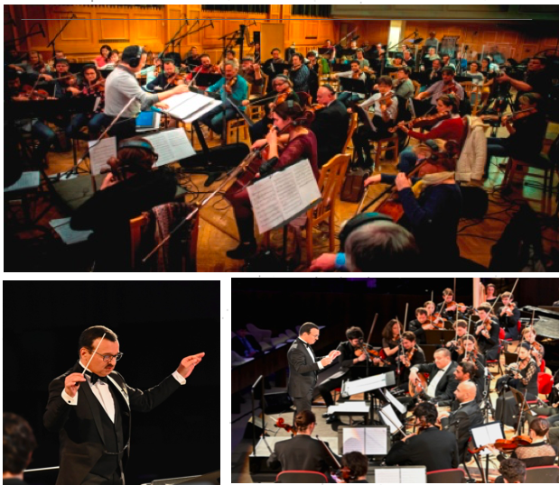

links

Web site : www.waheedalha.com * Facebook : waheedlkahn
YouTube ch. : Waheed Alkhan * Instagram : waheed Alkhan

Facebook: @waheedahmedalkhan

Instagram: @waheedalkhan

Website: https://www.waheedalkhan.com/music

Youtube: https://www.youtube.com/waheedalkhan

